NSQA
Newsletter
April 2018
____________________________________________________________________________________________________________________
National Saleyards Quality Assurance Inc. IAN A0050263X ABN 76 657 458 542

Postal address: 518 Bamganie Road, MEREDITH, VIC., 3333

Phone: 0422 312 607 E-mail: nsqa@bigpond.net.au www.nsqa.com.au

President: Ian O’Loan OAM Executive Officer: Mark McDonald

President’s Report

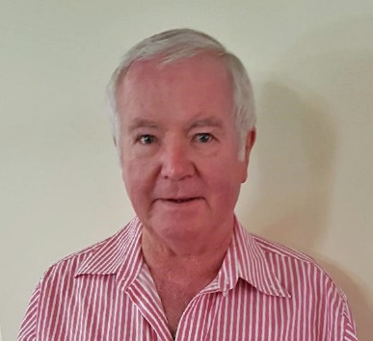

You will have received an earlier email to members regarding the NSQA Executive Officer. The board welcomes Mark McDonald to the role. With his industry experience Mark has come in with his feet on the ground. The changes foreseen in the past are now coming to fruition with newsletters electronic and the website becoming more user friendly.

Animal Welfare is an ongoing issue at saleyards, closely monitored by activist organisations. Under NSQA code of practice animals classified as “not fit to load” are not able to be presented for sale. It is the duty of receiving staff not to accept these animals or if requiring destruction to remove them to areas with no public access as soon as possible. Producers should be better educated re transport of these animals along with the transporters.

I am aware a lot of these instances occur with small producers who don’t have on property contact with livestock agents, education is difficult, but the only way NSQA yards can uphold their standard is by not accepting animals not fit for sale.

For saleyards not yet accredited to the current revised national standards (2017) the “No Name Saleyards Manual” will be updated shortly to include the new revised standards.

A familiarisation presentation has been prepared to assist both accredited and non-accredited yards moving to accreditation, this pilot will be presented at forthcoming ALMA mangers meeting.

Ian O’Loan OAM President

NEW EXECUTIVE OFFICER

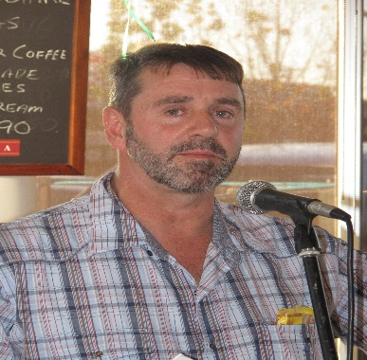

NSQA has recently employed a new Executive Officer to replace the retiring David Pollock. This is Mark McDonald who commenced his role in early February. Mark is based in Central Victoria on a small farm south of Ballarat. He has a long career with agriculture which includes almost 20 years in the wool industry, cropping R&D and private consultancy covering the Dairy, Irrigation and red meat industry. He is also the executive Officer for ALSA and has operated this role for the last 8 years.

VALE DAVID POLLOCK

NSQA regrets to advise that our long standing executive officer Mr David Pollock passed away on March 29 after a short illness.

The NSQA board had recently provided our outgoing Executive Officer David Pollock with a Certificate of Appreciation for his outstanding long term role in various industry organizations including NSQA. David was a founding party to the creation of NSQA over 25 years ago and has served as a director and then executive officer since this time.

David has also worked for LSAV, the Victorian Stock Agents Association, NASSO< NCWSBA and the livestock transport association over the last 2 decades and has provided a professional service to all of these organizations during this time.

STREAMLINING ANNUAL ACCREDIATION AUDITS

The most recent AUSMEAT quarterly report provide details on the uptake of the new pre audit process that is designed to reduce the time and cost of the AUSMEAT annual audit. Based on their figures around 50% of audited members for the designated time frame were undertaking this pre audit internal audit process. They indicated that most yards that undertook this pre audit process resulted in reduced costs for the subsequent AUSMEAT audit.

The NSQA board welcomes this uptake of the new process and encourages all members to consider this when preparing for their next annual audit. If you are unsure of the process please contact the executive officer for further details.

EU Audits will also continue be co-ordinated with NSQA Audits.

2018-2020 NSQA BOARD ELECTION

This year is election year for the NSQA board to elect a committee for the 2018-2020 period. The nomination papers for committee members (5 in total) will be circulated in mid-June and members will have until July 31 to nominate a representative. Following nominations members will be voting for the new board if we receive more than 5 nominations.

After the election and AGM the new NSQA board will elect the various committee positions.

ELECTRONIC COMMUNICATIONS

Recently you should have received a number of emails from the executive officer. This has been via a new NSQA members email list. In the future this list will become the main means of active communication to members. This will include newsletters, annual accreditation certificates and other NSQA news. You are free at add additional parties to this list so that we get our message to the relevant staff within your organization.

At this stage the board election papers will still continue to be circulated by post for this year’s election.

NSQA MEMBERSHIP SURVEY

The NSQA system has been operating for almost 20 years and has built up a membership base of around 80 Saleyards in all states. The NSQA board is keen to understand how the system works for its members and importantly what can be done to continually improve the membership experience. As such we will be releasing a member survey later this year to collect your thoughts and ideas.

INDUSTRY EVENTS

NSQA will at attending the ALMA and ALSA conferences in July and August respectively. This will be a chance to catch up with the new executive officer as well as raise any NSQA issues you have directly.

IF YOU HAVE ANY QUESTIONS ABOUT NSQA THEN CONTACT THE EXECUTIVE OFFICER – 0422 312607
nsqa@bigpond.net.au

Details are also at the AUSMEAT website
www.ausmeat.com.au
Just click on the NSQA Logo
Audits should be arranged by direct contact with Wayne Williamson at AUSMEAT
Phone: 07 3361 9211 0427 610 463

LIST OF CURRENT NSQA
ACCREDITED SALEYARDS
05/1998 Casino, NSW
29/2001 Coonamble, NSW
37/2002 Cowra, NSW
18/2000 Deniliquin, NSW
07/1998 Dubbo, NSW
14/1999 Finley, NSW Cattle only
41/2002 Glen Innes, NSW
39/2002 Gloucester, NSW
44/2003 Grafton, NSW
01/1998 Inverell, NSW
34/2001 Kempsey, NSW
40/2002 Lismore, NSW
36/2001 Maitland, NSW Cattle only
09/1999 Mudgee, NSW
35/2001 Narrabri, NSW Cattle only
30/2001 Singleton, NSW
21/2000 Wagga Wagga, NSW
22/2000 Yass, NSW
47/2004 Bairnsdale, Victoria
19/2000 Bendigo, Victoria
16/2000 Camperdown, Victoria
51/2014 Casterton, Victoria
08/1998 Colac, Victoria
33/2001 Echuca, Victoria
27/2000 Hamilton, Victoria
31/2001 Horsham, Victoria
46/2003 Kerang, Victoria
02/1998 Northern Victoria LE, Victoria
38/2002 Ouyen, Victoria
10/1998 Shepparton, Victoria
04/1998 Swan Hill, Victoria
12/1999 Wangaratta, Victoria
49/2010 Warracknabeal, Victoria
24/2000 Warrnambool, Victoria
50/2011 Wycheproof, Victoria
06/1998 Millicent, S.A.
26/2000 Mount Gambier, SA
28/2000 Naracoorte, SA
17/2000 Adelaide Plains. L’stock Ex. SA
11/1999 Biloela, Qld.
48/2005 Charters Towers, Qld
03/1998 Gympie, Qld.
32/2001 Moura, Qld.
43/2003 Central Queensland LE Qld
20/2000 Roma, Qld.
45/2003 Silverdale, Qld
52/2016 Warwick, Qld

