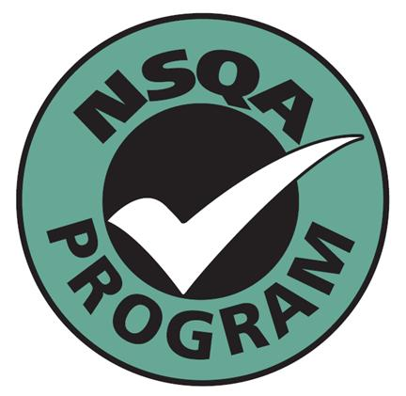
NSQA
National Saleyards Quality Assurance Inc. ABN 76 657 458 542

ELECTION OF COMMITTEE 2018-2020

CANDIDATE STATEMENTS – IN ORDER OF BALLOT PAPER

The information provided is reprinted from the Nomination Forms in the order in which they appear on the Ballot Paper which was by draw by the Returning Officer in the presence of the Association’s Auditor

Naracoorte Livestock Exchange nominated Hugh Ian O’LOAN OAM, PO Box 62, Mallala, SA, 5502

Ian O’Loan, President NSQA, previously Deputy President/Committee member. Member Naracoorte Regional Livestock Exchange Board the past 7 years. Saleyard consultant, auditor for LPA, LPA-QA and OJD/BJD programs. Maintains an active part in the family farming and pastoral operations in SA, the SA Livestock Exchange re-location from Gepps Cross and establishment at Dublin was initiated and managed by Ian and hence in 1997 was his initial involvement in NSQA. Have had over 20 years involvement in Local Government as Chair and also RDA at local and as RDSA Chair. In his current role instrumental in updating standards to incorporate present legislative requirements.

AAM Investment Group nominated Kenneth John ROGERS, 1R Beemery Rd., Dubbo, NSW, 2830

Ken holds a bachelor’s degree in applied science. He has worked in private enterprise and the public sector. In his former role as a Director at Dubbo Regional Council, his accountabilities included, among other things, the Dubbo Regional Livestock Markets.

Ken is currently an active member of the National Saleyards Quality Assurance (NSQA) Committee and the Australian Livestock Markets Association (ALMA) He has been a Board member of ALMA for the past six (6) years, and was re-elected to the Board in July this year and he is also the Deputy President of ALMA.

Ken represents ALMA on the Livestock Services Research and Innovation (LSRI) committee.

Warrnambool Shire Council has nominated Paul Gerald WHITE, 3 Kelp St., Warrnambool, 3280

Paul has overseen the development of systems and processes at the Warrnambool Saleyards over many years. To make the facility one of the safest and most efficient in the industry. Warrnambool despite its age of infrastructure remains one of the fastest most efficient selling centres in the country due to the systems work implemented by Paul.

White have been in the saleyard industry for 18 years and have a wide range of experience in all aspects of quality assurance. Warrnambool saleyard obtained QA in 2000.

Finlay Saleyards nominated Grant JOHNSON 27 Tigermoth Avenue, Temora, NSW, 2666

Grant Johnson was directly involved in the strategic management of the Wagga Wagga Livestock Marketing Centre from September, 2007 until April, 2016. Since then he has been a Director with nearby Junee Shire Council and he maintains a close association with the Wagga Wagga LMC and the broader livestock industry. He has been a Member of the NSQA committee for the past six years and actively participated in the recent review of the national standard and other NSQA reforms. He has past quality assurance system experience from manufacturing industry roles.

Western Australia Meat Industry Authority nominated David Michael SAUNDERS, 510 Highlands Drive, Parkerville WA., 6081.

Recently retired after 47 years in the Government Agricultural industry I currently I run a consultancy and sheep trading enterprise using the saleyard system. Previously my role was in senior management developing strategy and standards for the Muchea Livestock Centre’s which is a new state of the art facility which operates under the highest auditable standards.

My skills including infrastructure design, project management, industry communication, animal welfare compliance and OH&S. I am committed to the saleyard industry and believe my skills mix will enable me to continue to contribute positively to the NSQA program. I would seek your support for a further term to further improve our industry through the NSQA program

City of Greater Bendigo nominated Kerrie CROWLEY, PO Box 733, Bendigo, Vic., 3552

Kerrie Crowley manages the Bendigo Livestock Exchange which is NSQA Accredited sheep, cattle and pig livestock facility and is the largest NSQA accredited sheep and lamb facility in Victoria. She offers a voice for all members of NSQA that is focused, informed and practical. A voice which benefits from day to day operation of a saleyard and identifies the challenges saleyard managers face in the practical implementation, problem solving, training, audits and facilitation of the NSQA program.

Kerrie is committed to NSQA outcomes that will reflect changing industry standards while maintaining a practical approach to saleyard management.

Charters Towers, Gracemere Saleyards and AAMIG nominated Ian Bruce Lovegrove, 198 Allen Road, Gracemere, QLD, 4702

Ian Lovegrove has a lifetime of experience in Saleyards and livestock marketing. Ian is committed to the improvement of live auction selling and the facilities that provided these services. Ian has an outstanding relationship with Northern Australian facility operators and a proven record of engagement and facilitating increased participation in projects equivalent to those that underpin NSQA.

